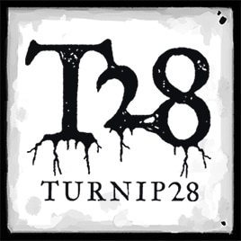

**R*OOT*F*EST* 25**

**“*C****hurned mud and swampland stretches out into the gloom. Thick foul fog hangs heavy in the air. Rolling barrows loom out of the murk. A strange root writhes incessantly, worryingly underfoot. A thousand years after the defeat of Napoleon at the Battle of Austerlitz, an alternative world has collapsed into the abyss of decay. Endless eons of war have led to technological stagnation, and once beautiful country sides have been ground down into a thick, ruinous gloop by the boots of a million dead men. Now, nothing grows.*

***A*** *bizarre and horrible alien root now covers the land, strangling the life from the trees, poisoning the water, and filling the skies with an acrid mist. Humanity barely endures by harvesting this disgusting tuber. It twists their bodies and minds, infesting their thoughts with divine visions of long lost vegetables. Bizarre religious orders have formed. They stockpile abandoned weapons unearthed by the twisting roots. Marching in ragged columns under torn fluttering banners, brandishing mud-clogged muskets crowned by rusted bayonets, they are but cruel parodies of once noble, now long-forgotten armies.*

***G****ather your troops.* ***F****ix bayonets.* ***A****bandon all hope, and* ***D****evote yourself to the* ***R****oots.****”***

**Turnip28** is a post-apocalyptic vegetable wargame. Players command Regiments of fantastic miniatures made up of incompetent Snobs, bedraggled Followers and bizarre war machines. You will weep. You will cheer as deranged peasants kick each other to death in the all-pervasive, root infused mud.  
  
A **FREE** print friendly version of the rules **(Playtest V.18)** is available here: https://www.patreon.com/posts/turnip28-core-117901030

The **Turnip28** community is unlike any other in the broad church of our hobby, being far closer to an artistic movement than any cut throat competitive environment. The rules themselves are available for free and the game is completely figure agnostic, making this the perfect vehicle through which to unleash the beasts of your imagination. (And to recycle those figures left over from previous gaming passions.)

**RootFest 25** aspires to be a continuation of the excellent Turnipment run at **ShireCon 25** by **June Fisher**, to the point where we are shamelessly recycling most of her Players’ notes (almost verbatim). Those who were able to indulge themselves utterly in that delightful day at ShireCon will be very aware of the fantastic communal vibe which we now seek to emulate at MOAB on Saturday, 4th October (yes, this will be a one day event, of 4 rounds).

Please contact the Turnipment Organiser, Richard “oozeboss” Naco at [richard.naco@hotmail.com](mailto:richard.naco@hotmail.com) for a Players’ Pack, or with any enquiries.

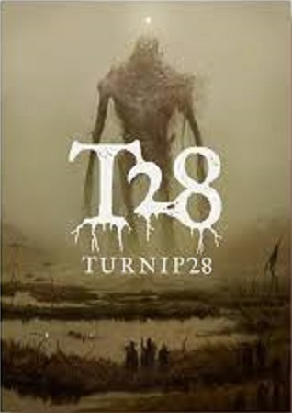

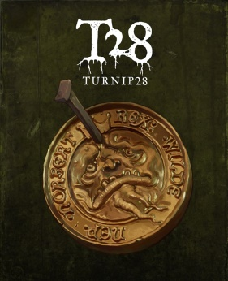

**R*OOT*F*EST* 25**

**Players’ Pack**

**Communications**: Event updates will be posted on the Down Under Empire Discord server, which you can join here: https://discord.gg/rGyFQzSprZ All RootFest25 inquiries should be sent to [richard.naco@hotmail.com](mailto:richard.naco@hotmail.com), or directly messaged to oozeboss on the Discord server.

**Date + Location** : Saturday 4th of October, 2025(AD), at Sylvania Heights Community and Youth Club, 288 Box Rd, Sylvania NSW 2224

**Rules + Format**: We will be using the V18 Playtest rules. If a full release comes out before the date, we will likely switch to using those rules and an amended player pack will be released. We will be allowing cults from the Mercenary Cults expansion and Lumps from the Lump playtest. **V18 Playtest Rules and Lump Playtest**: https://www.patreon.com/posts/turnip28-core-117901030?utm_medium=clipboard_cop y&utm_source=copyLink&utm_campaign=postshare_fan&utm_content=web_share **Mercenary Cults**: https://drive.google.com/drive/folders/14WQVyVyaeIWcwYWk9T07QiDFIIIIh_cL?usp= drive_link

**Schedule:** 08:45am - Registration + Briefing 09:00am - Start of Round 1 10:30am - Start of Round 2 (we will be allowing 2 1/2 hours for this round, to include an inevitable lunch/ retail therapy break) 1:00pm - Start of Round 3 2:30pm - Start of Round 4 (this round will end at 4:00pm-ish) 4:00pm - Prize Giving/ Event Debriefing/ Photo Opp/ + collective Group Hug, followed by pack up.

**Playable Forces:** All Regiments will consist of 1 Toff, 2 Toadies, and 4 Follower Units. Any Cults listed in either the Core Rules or the Mercenary Cults may be used. Adoptions (aka Pets) will not allowed at this event unless via Wandering Morris. **\*\*\*\*\***This is a friendly event and we strongly encourage people to bring enjoyable lists. This will not be a highly competitive environment**\*\*\*\*\*** Armies should be based (multibasing is okay), and (hopefully) fully painted.

We ask that all players declare which Cult they will be playing by no later than Friday 26 September, so that army lists can then be tweaked in the context of possible opponents. Send these notifications to [richard.naco@hotmail.com](mailto:richard.naco@hotmail.com) - the list of Cults will be posted on the various T28 Discord and Facebook pages for public perusal (without identifying who is running which Cult) by Monday 29 September. The actual Army Lists should then be submitted to the same address by no later than Friday 3 October.

**What to bring:** ● Your Regiment (although the Turnipment Organiser - TO - may have some Regiments available for loan, on a first come/ first serve basis). ● Accessories - Dice, tape measure, and army rules. It is recommended that you write the rules for your followers and Cult on a single piece of A4 paper so you don’t need to flick through the rulebook. ● Prize Donation - If anyone would like to donate to the prize pool with something from their pile of shame, that would be greatly appreciated. The prize pool will solely comprise the pre-loved plastic + pewter of our playing cohort, and our hope is for all players to be able to give a good home to a previously underappreciated piece of gaming or artistic material. ● It would also be appreciated if players could provide some terrain, as the availability of this may be the most significant determinant impacting upon the size of our event.

**Scenarios:**  Scenarios are currently being planned out, but will be picked from the Core Rulebook and the Turnip Taster Campaign. All games will be played on 3’ x 3’ playing surfaces. Each table will have a unique scenario ascribed to it, and players will rotate between tables (+ scenarios) for each round.

**Scoring**: Players will gain points over the course of the day. At the end of each game, each player should tally up their points on a score sheet, which will be provided.

**Prize Categories:** These will be as follows (and please note that players may only win one category) - ● “Stranglin’ Harry’s Bastard Childe” - The highest scoring player. ● “Tod’s Newest Bestest Mate!!!” - The lowest scoring player. (Note: Tod’s newest bestest mate just might get first dibs at the prize pool – this is Turnip after all.) ● “Syphillus the Magnificent, Redux” - That Artist whose Visions Splendid made all us mere mortals absolutely green with envy. (This will be decided by a secret ballot of all participants, with the TO retaining the right to … quietly, shhhh … resolve any tie.)

