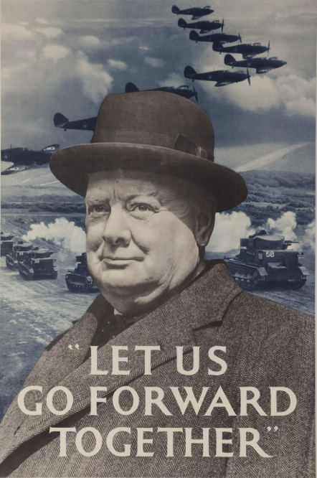
MOAB 2026
Flames of War

T.O Ken Snell
Sponsored by
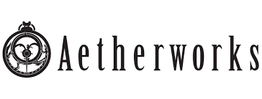

Hello! Welcome to the player pack for the Flames of War event at MOAB 2026, brought to you by Canberra Flames of War, we’re happy to help foster and rebuild communities with good spirits and sportsmanship.

Dates | 3 – 4 Oct 2026
Venue | Sylvania Heights Community and Youth Club
TO | Ken Snell (kakes1fs@gmail.com)
Rules & Era | Flames of War V4,Early War
Forces | 100 Points, Blitzkrieg Book (No wild cards)
Facebook Group | Flames of War @ MOAB | Facebook

Flames of War’s return to MOAB in 2025 was well attended and great weekend and it's time to have blast rolling dice with little toy soldiers again in Sydney! Come along and play with great people in greater spirits. It shows when the ‘Best Sports’ award is always the most hotly contested how great our community is.

If you are new to the system, an experienced vet, or if you are looking at stepping back into the game, all are welcome! If you don’t have an army ready for the table, loan armies are freely available, please don’t hesitate to ask.
Missions will be picked and scored as usual using the Battle Plans matrix from the Mission Pack (December 2024) pack and players ranked using the Swiss Chess method to avoid seal clubbing at the bottom. If a result of Rearguard is rolled, players may reroll the mission.
SCHEDULE

Day 1 (3 Oct 26) | Day 2 (4 Oct 26)
0830 – 0900 Arrival, Registration | 0830 – 0900 Arrival, Registration
0930 – 1200 Game 1 | 0930 – 1200 Game 4
1200 – 1230 Lunch | 1200 – 1230 Lunch
1230 – 1500 Game 2 | 1230 – 1500 Game 5
1530 – 1800 Game 3 | 1500 – Results & Awards
1900 – Tournament Dinner (Details TBA)

GAMES:
Games in the tournament will be played at 100pts Points. Games will be given 2.5 hours.

Games will be scored using the normal rules, and these results will be used to make the draw for the next round. The first round draw will be randomized (grudge matches will not be allowed) and subsequent games will be paired with the Swiss Chess system.

FORCES:
Forces may be drawn from the Blitzkrieg book. Forces will should be submitted to the TOs 1 week before the event by email.

To enable historical match ups, Players may bring both red (German) and blue (in this case British or French, but not both) lists. Rules are:

- In the event a player has only one list, the opponent must play with their historical opponent list.
- In the event both players have two lists and both wish to play either blue or red, then players will dice off for choice. The opponent must then play with their historical opponent list.

No wild cards. Lists (preferred that they’re generated through Forces of War) are to be submitted to the TO NLT 28 Sep 26.
T.O. Decisions:
Rugby Law 6: ‘The referee is the sole judge of fact and law’. Players are expected to be familiar with Flames of War 4th Edition rules and the latest Lessons From the Front. Should disagreements occur, players are encouraged to sort the issue out themselves, but if needed may confer with the TO. If the T.O. is called in to mediate, then their decision is final (even if wrong, it is right).
Players are reminded that this is a friendly event, even with the competition. Ample time has been allotted for games, so relax and have fun, we’re here to have a blast and tell a cool story with our toy soldiers.
Should players be caught deliberately misinterpreting rules, acting in a non-sportsman’s like manner or deliberately acting in an antagonistic manner, they may be asked to leave and dropped from the event without refund.
Models and WYSIWYG:
Players should make every effort to field a fully painted force (minimum 3 colour standard) that accurately reflects the army list they have chosen.
Models should be easily identifiable as to what they represent. Substitution or ‘proxying’ is allowed to a degree, however, the models should be suitable for what they represent (a Panzer 3 is a Panzer 3 of another type). If players are running multiple versions of the same tank within their force or within a platoon, the models should be consistent across the full force in what they represent (a Panzer 3 E shouldn’t be one thing in one platoon and something different in another).

Terrain:

Like always, to effectively run this event we will require players to donate terrain for use on the weekend. All measures will be taken to keep players' terrain safe, and players are to take care with the provided terrain, but no guarantees can be made. Events like these run on the goodwill of people willing to share the results of their labor, and that should never be overlooked (unless you like playing on featureless grassy plains).

Please let TO’s know if you can supply terrain.

We look forward to welcoming you back to MOAB!

Discussions and updates will be posted here, so please join if you haven’t. Any questions or clarifications will be communicated through the Facebook group.
Available on the facebook group. Every player should have a copy handy.
This mission often doesn't work well in a tournament setting due to time constraints.

