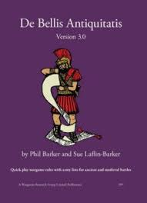**15mm DBA v3.0 MOAB 2025**

**Mother of All Battles** (MOAB) is back for 2025 and will be held over the NSW Labour Day weekend (4th– 6th October 2025). DBA is played on the Saturday and Sunday. You can play either or both days. Most participants play two days. Each day starts at 9:00am with a briefing, and play starts shortly afterwards.**At this stage, there will be a limit of 20 players per day**.

MOAB is held in the main building of the Sylvania Heights Community & Youth Club, in the Sylvania Heights reserve off Box Road, Sylvania Heights (southern Sydney). Motel accommodation is available nearby.

# **DBA on Saturday:**

# **Hot Wheels**

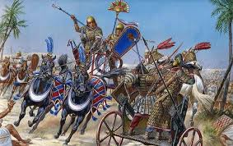

**Playing Conditions**

Each player is to field a 12 element army that must contain at least 3 chariots. Chariots of all types are allowed. Twenty nine armies, without allies, have been identified across Sections 1 and 2 of the Army Lists. If you wish to field an army that has only 2 chariots, you can use an ally to achieve the minimum of 3 chariots. However, if you use an ally, the majority of the chariots must be provided by the main army. For example, I/51 has 2 chariots and can be allied with I/42, which only contains 1 chariot. **Dismounting is not permitted throughout the game.** After, all, the theme is chariot warfare.

**Please Note: For those contemplating playing in this competition, but without an eligible army, there will be a limited number of armies available for loan.**

# **DBA on Sunday:**

# **Pasta Wars**

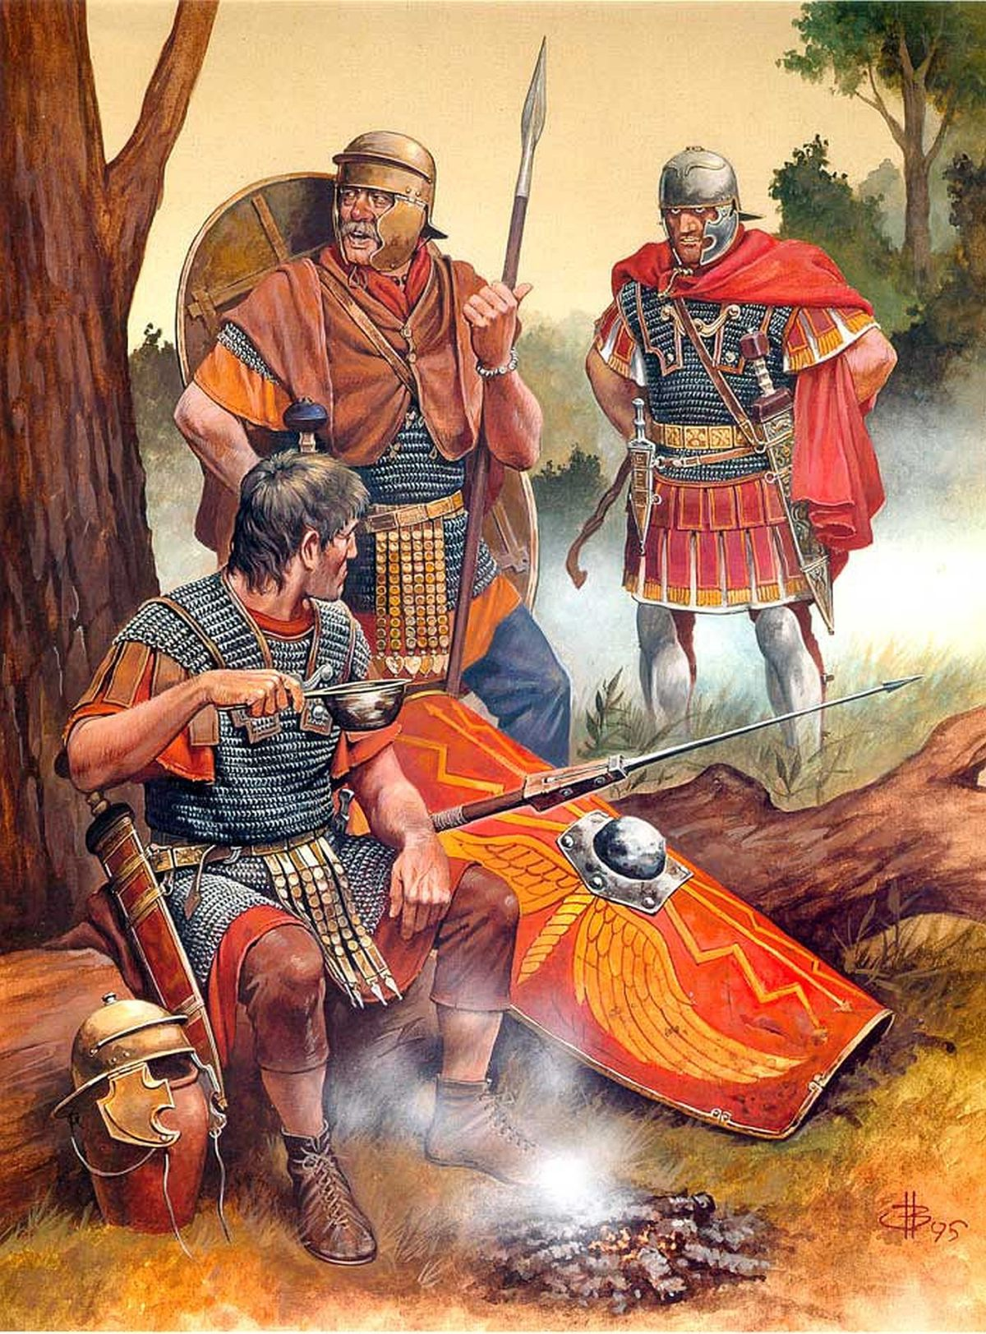

**Playing Conditions**

Each player is to field a 12 element army that had their political entity based in modern day Italy. In excess of 50 armies, across all 4 Sections of the Army Lists, fit the geographic criteria. If you wish to use an ally for **Pasta Wars** an approved ally must come from the list of eligible armies**. Dismounting at either deployment, or during game play, is permitted as per the rules.**

**Please Note: For those contemplating playing in this competition, but without an eligible army, there will be a limited number of armies available for loan.**

**Rules: DBA v3.0 (including any official amendments released by the author).**

**Rule Variations for both days**

Scoring will be**:**

* Winners receive 8 points for a win.
* Losers receive:
  + 1 point for finishing the game,
  + + 1 point for each enemy element killed (up to a maximum of 3 points),
  + + a bonus point for killing their opponent’s General + a bonus point for capturing their opponent’s camp.

Maximum score for a lost game is 6.

* Drawn games are scored:
  + 1 point for each enemy element killed (up to a maximum of 3 points)
  + + a bonus point for killing an opponent’s General
  + + a bonus point for capturing an opponent’s camp.

Maximum score for a drawn game is 5.

**Camps must have camp followers (CF), or be garrisoned by one of your army’s 12 elements. If either of these conditions is not met the camp is considered undefended.**

Figures are to be based for 15mm scale (i.e. 40mm frontage). Games will be played on 70cm2 boards. Game duration is 1 hour with the next round commencing at most, 15 minutes after the scheduled finish of the previous round.

Players are encouraged to provide their own terrain, though there may be a small pool of terrain pieces.

**Army lists, detailing the list number, the 12 elements being used, and the army’s date are to be sent to me by Friday 26th September 2025 at the email address below.**

Lists of eligible armies for *Hot Wheels* and *Pasta Wars* can be obtained by emailing me (Greg Kelleher) at [dba.moab@gmail.com](mailto:dba.moab@gmail.com)